- Got to crmurl/main.aspx?settingsonly=true
- Go to customize the system ->entity
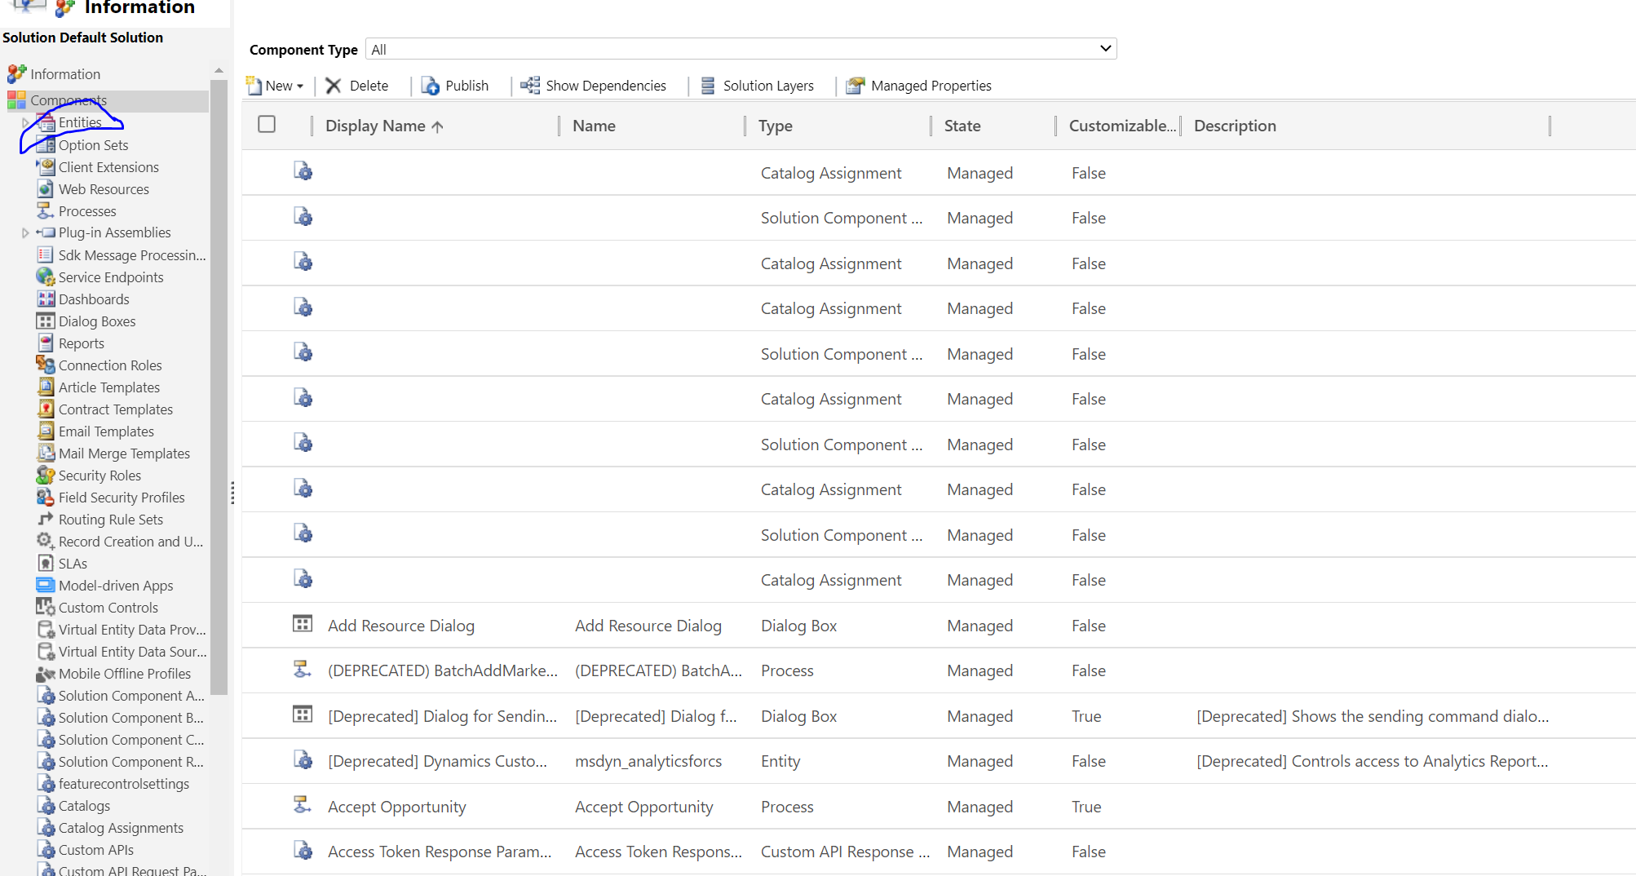
- For any custom entity , create a field with data type multi select option set
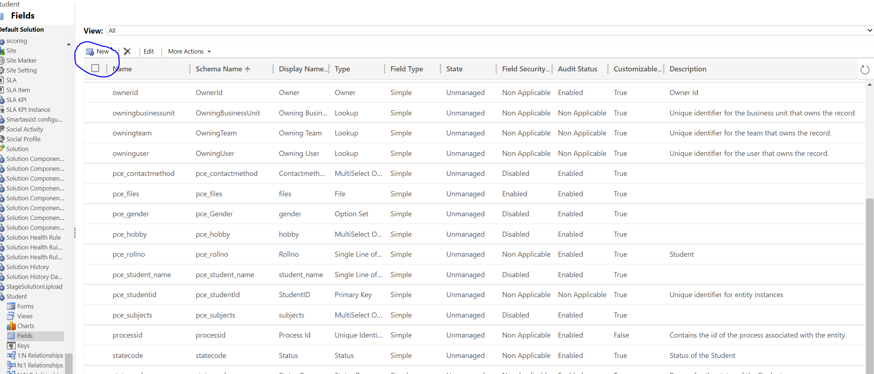
- Enter every details


